ALMP – Driver on demand

Business Case

|  |  |
| --- | --- |
| Business Case | |
| Project Title | *ALMP Fleet management* |
| Project Sponsor | Ramandeep Singh Virdi |
| Project Manager: | Arman Singh |
| Technical Manager: | Vinod Kumar Tiwari |
| Project Owner: | Dheeraj Pant |

**Document Control**

|  |  |  |  |  |  |
| --- | --- | --- | --- | --- | --- |
| Version No. | Date | Author | Change History | Reviewed By | Approved By |
|  |  |  |  |  |  |
| V 0.0.1 | 12-10-2023 | Vinod Kumar Tiwari |  |  |  |

Contents

1. Executive Summary 4

2. General Information 4

3. Project Description 4

4. Benefits, Goals and Measurement Criteria 4

5. Delivery Cost and Funding 5

6. High Level Business Impact 6

7. Alternative Analysis 6

8. Preferred Solution 7

9. Risks 7

10. Issues 7

11. Assumptions 8

# ExECUTIVE SUMMARY

ALMP will be the next innovative fleet management solution to improve productivity and reduction in cost by making the effective utilization of drivers and the available vehicles by embedding smart devices which can help in real time vehicle data tracking using MQTT protocol by IoT integration with Americana Last Mile Platform (ALMP) services to achieve the following set of business goals:

* Driving Behavior Assessment
* Crash Alerts
* Training Requirement for Safe Driving
* On-trip & off-trip Monitoring
* Green Points Strategy for Riders
* Assets Utilization
* Improve rider tracking journey for order tracking.

# GENERAL INFORMATION

Americana innovative fleet management solution to improve productivity and cost reduction by integration of IoT with available rider’s vehicle tracking and best utilization of riders and vehicles.

# PROJECT DESCRIPTION

With an integration approach with IoT devices setup with the vehicles to existing Americana Last Mile Platform product to achieve more efficient utilization of riders and vehicles to optimize journey and order delivery experience.

**Automate Feedback for Drivers**

Implementing a scoring approach that applies across multiple dimensions allows management to evaluate good or poor driving ability effectively. When used correctly, taking an automated approach improves performance across the board by rewarding good driving, targeting drivers who need review, and exposing hidden behavior trends.

**A strong AI approach might introduce mechanisms for:**

Overall score, with component behavior scores aggregated based on risk, used to coach drivers.

Assigning 1:1 coaching based on patterns of undesirable behavior and a lack of self-correction after receiving automated feedback.

Identifying true speeding that needs to be addressed with reduced false-positives

Determining irregular fuel transactions or use

**Optimize Fleet Delivery Routes and Schedules**

Fleets specializing in product or service deliveries must be highly efficient to meet customer demands. Fleet management software may help monitor vehicles en route and in real-time, promoting efficiency.

Appropriately planned routes (Fleet Optimization) and timely deliveries are a must for boosting customer satisfaction, making it critical to provide precise arrival times and narrow appointment windows. Leveraging fleet management software to analyze vehicle and driver data can help management determine delivery times, keep customers updated, and identify more optimal routes (if any).

By managing drivers’ jobs and schedules in real-time, routing adjustments can be made to shorten delivery times.

**Track Service/Appointment Verifications & Exceptions Automatically**

Having the ability to make and verify service and appointments streamlines daily operations, reducing or eliminating the need for manual follow-up procedures to accomplish the same task. These verifications can be applied for multiple services (delivery, transfer, collection, etc.) to prevent delays or missed connections and ensure customer satisfaction.

These automations include features such as:

ETA Calculations: Automatic calculation of driver ETA, accommodating for traffic, road closures, weather, and other driving conditions that might affect driver time of arrival.

Customer Updates: Automated messages informing customers of any changes in delivery-related information are sent without the need for manual effort.

Visit Verification: Confirmations for services and appointments are automatically sent to the customer, allowing for quick and easy 2-party verification.

Progress Reports: Delivery information is automatically compiled and made available to management with automated notifications only when attention is required

**Reduce False-Positive Indications of Undesirable Driving Behavior**

Reviewing suspected undesirable driving events manually wastes valuable time and energy. Using automated strategies to examine and review undesirable driving behavior (for example, speeding violations) across your entire population of drivers saves time by providing essential information and filtering out inaccurate data automatically, allowing for quick and final decisions.

Reducing false positives streamlines daily operations and cuts down on one of the largest wastes of time in the industry. This leaves you and your team available to more specialized work deserving of attention, thus improving the overall efficiency and performance of your fleet.

# Benefits, Goals and Measurement Criteria

**Vehicle Availability**

Measure and optimize fleet performance to meet business goals, using real-time or historical data trends, helping you make quantifiable business decisions that help cut operating expenses and improve productivity.

**Driver Behavior**

Measure and optimize fleet performance to meet business goals, using real-time or historical data trends, helping you make quantifiable business decisions that help cut operating expenses and improve productivity.

**Maintenance Cost and Time Reporting**

Measure and optimize fleet performance to meet business goals, using real-time or historical data trends, helping you make quantifiable business decisions that help cut operating expenses and improve productivity.

**Fuel Maintenance**

Measure and optimize fleet performance to meet business goals, using real-time or historical data trends, helping you make quantifiable business decisions that help cut operating expenses and improve productivity.

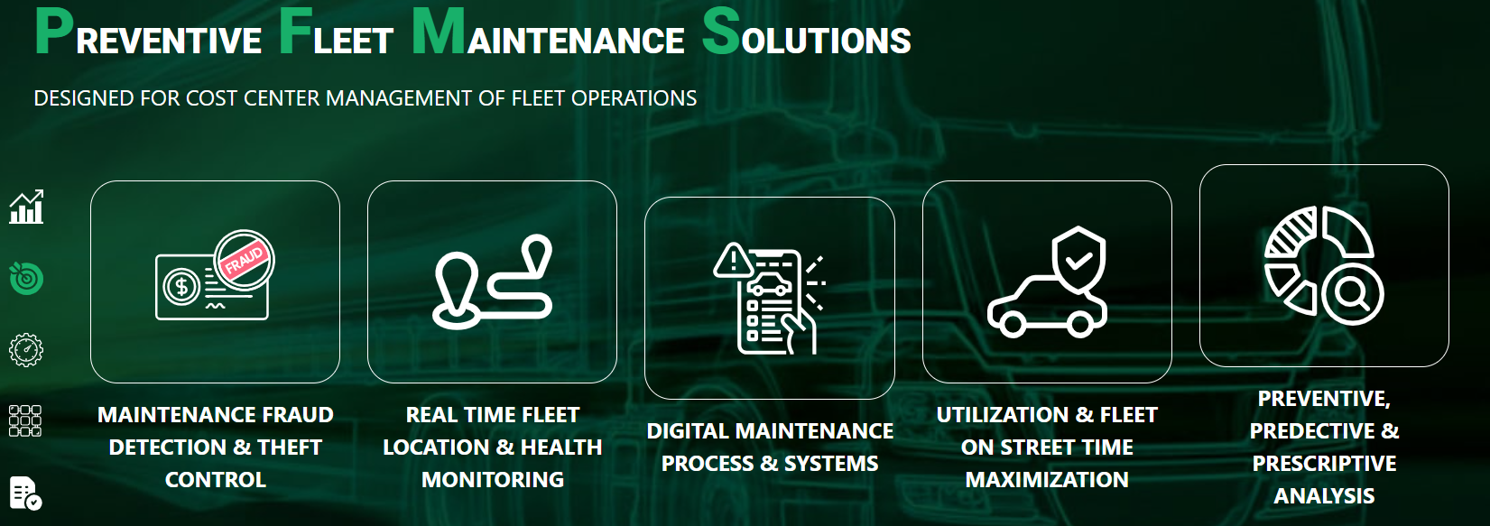

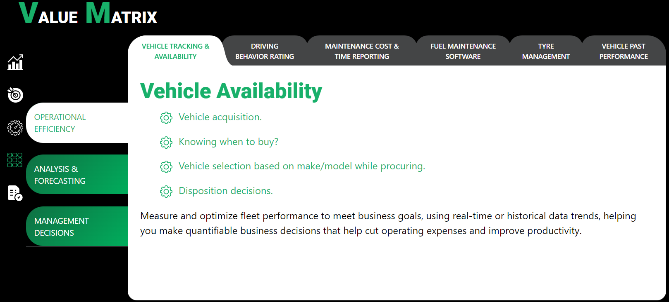

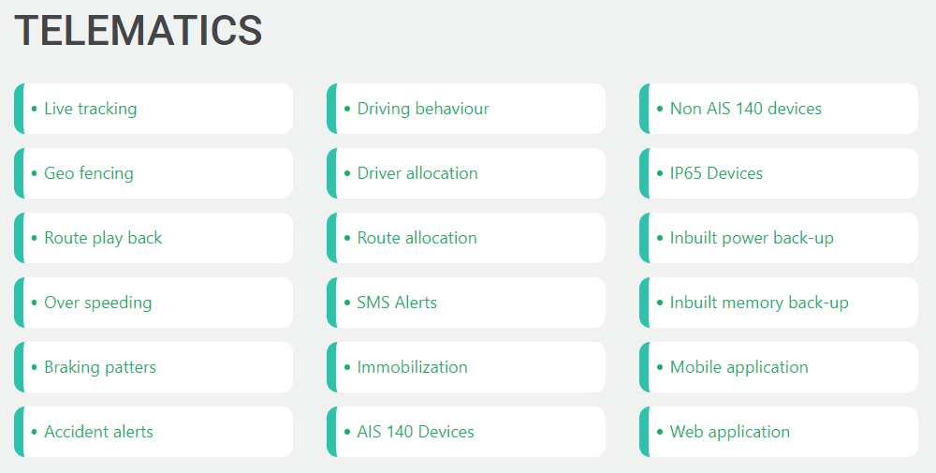

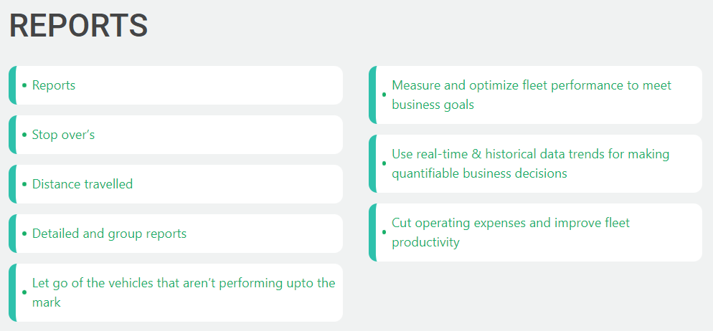

*1. HIGH LEVEL BUSINESS IMPACT*

*Outline which business functions/processes will be impacted and describe how the Organization will need to react in order for the project to be successful. Outline plans for supporting ongoing operations. Also consider additional resource requirements, staffing, training, security etc. and be sure to include these in the Investment Appraisal*

|  |  |  |
| --- | --- | --- |
| **Category** | **Benefit** | **Value©** |
| *Financial* | * *New revenue generated* * *Reduction in costs* * *Increased profit margin* | *$ x*  *$ x*  *$ x* |
| *Operational* | * *Improved operational efficiency* * *Reduction in product time to market* * *Enhanced quality of product / service* | *x %*  *x hrs*  *x %* |
| *Market* | * *Increased market awareness* * *Greater market share* * *Additional competitive advantage* | *x %*  *x %*  *Describe* |
| *Customer* | * *Improved customer satisfaction* * *Increased customer retention* * *Greater customer loyalty* | *x %*  *x %*  *Describe* |
| *Staff* | * *Increased staff satisfaction* * *Improved organizational culture* * *Longer staff retention* | *x %*  *Describe*  *x %* |
| *Others* |  |  |

.

# Delivery Cost and Funding

Please provide high level estimates of duration and call out any specific delivery considerations such as the use of 3rd parties etc.

*Describe the tangible and intangible costs to the company upon implementation of the solution. The costs of the actual project should be included (e.g. equipment procured) as well as any negative impact to the business resulting from the delivery of the project (e.g. operational down-time). Complete the following table. Below are few examples to consider.*

|  |  |  |  |
| --- | --- | --- | --- |
| **Category** | **Cost** | **Value** | **Budgeted** |
| *People* | * *Salaries of project staff* * *Contractors / outsourced parties* * *Training* | *$ x*  *$ x*  *$ x* | *YES*  *NO*  *YES* |
| *Physical* | * *Infrastructure* * *Equipment and materials* * *Tools (computers, phones…)* | *$ x*  *$ x*  *$ x* | *NO*  *NO*  *NO* |

*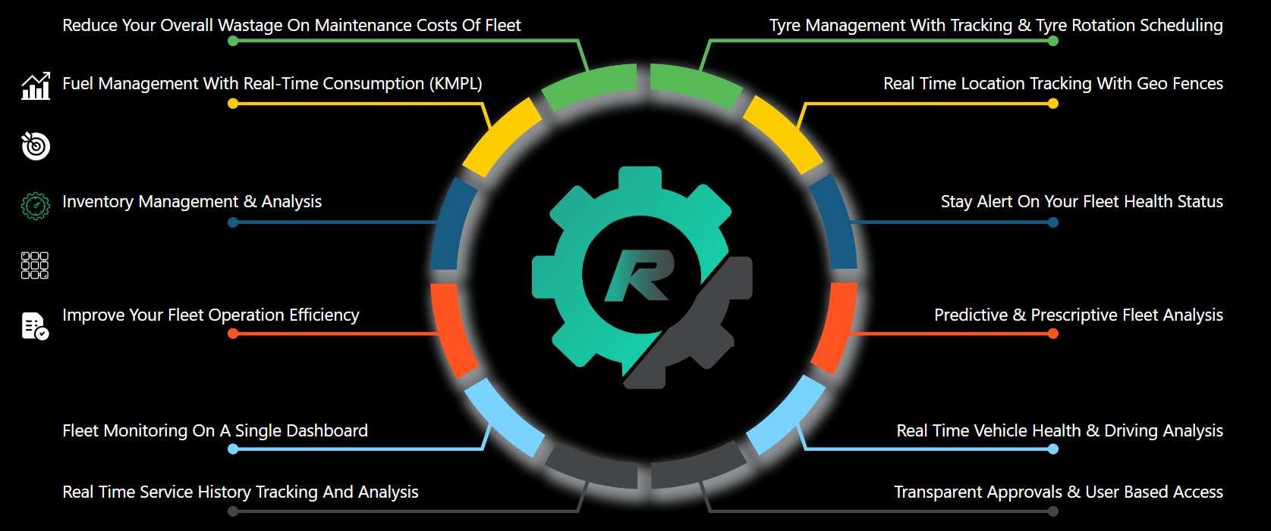In addition, you may need to identify whether the cost item is a capital (CAPEX) or operational (OPEX) expenditure item. A separate spreadsheet showing an analysis of the cost equations may need to be attached as an appendix to this document if further information is likely to be required for approval.*

# Risks

*Summaries the most apparent risks associated with the adoption of this solution. Risks are defined as “any event which may adversely affect the ability of the solution to produce the required deliverables”. Risks may be Strategic, Environmental, Financial, Operational, Technical, Industrial, Competitive or Customer related. Complete the following table:*

|  |  |  |  |
| --- | --- | --- | --- |
| **Description** | **Likelihood** | **Impact©** | **Mitigating Actions** |
|  |  |  |  |
|  |  |  |  |
|  |  |  |  |
|  |  |  |  |

*To complete this section thoroughly, it may be necessary to undertake a formal Risk Assessment (by documenting a Risk Management Plan). To reduce the likelihood and impact of each risk's eventuating, clear ‘mitigating actions’ should be defined.*

# Assumptions

*List the major assumptions associated with the adoption of this option.*

|  |  |
| --- | --- |
| **Assumption** | **Actions to validate Assumptions** |
|  |  |
|  |  |
|  |  |

Appendix A: Business Case - Approval

The undersigned acknowledge they have reviewed the *<Project Name>* **Business Case** and agree with the approach it presents. Changes to this **Business Case** will be coordinated with and approved by the undersigned or their designated representatives.

[List the individuals whose signatures are desired. Examples of such individuals are Business Steward, Implementation Manager or Project Sponsor. Add additional lines for signature as necessary. Although signatures are desired, they are not always required to move forward with the practices outlined within this document.]

|  |  |  |  |
| --- | --- | --- | --- |
| Signature: |  | Date: |  |
| Print Name: |  |  |  |
| Title: |  |  |  |
| Role: |  |  |  |

|  |  |  |  |
| --- | --- | --- | --- |
| Signature: |  | Date: |  |
| Print Name: |  |  |  |
| Title: |  |  |  |
| Role: |  |  |  |

|  |  |  |  |
| --- | --- | --- | --- |
| Signature: |  | Date: |  |
| Print Name: |  |  |  |
| Title: |  |  |  |
| Role: |  |  |  |